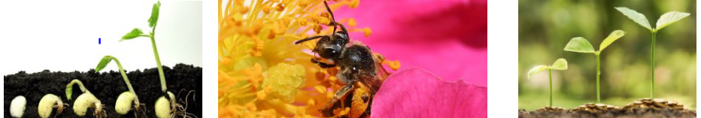
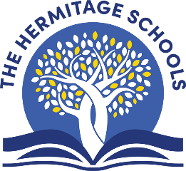
Inspiring Everyone To Learn
Trips/Workshops: We have our Kew Gardens trip on Thursday 11th June.
Value of the half –term: Cooperation. What does this mean? Why is it important?

Family Learning Ideas: Visit Wisley Gardens. Grow your own plants and vegetables. Create art using natural materials. Take a walk around your local area. Make a list of sights and sounds.

Scientists: We will be learning about the parts of flowering plants and what their purpose is, the life cycle of a plant, as well as pollination, germination and seed dispersal.
Readers: Using Destination Reader, we will continue being super readers by revisiting the different aspects of reading: questioning, clarifying, inferring, predicting, evaluating, summarising and making connections.
Spellers: This term we will finish our Y3 patterns, including: prefixes (im-, re-, anti-, super-, sub-), suffixes (-ation, -ion,-ture, -ian) and different pronunciations of ‘ch’
Writers: We will be reading ‘Charlie and the Chocolate Factory’ and writing letters, adverts and creating our own room in the factory!
Mathematicians: The maths topics this half-term are: money, time and arithmetic. We will continue weekly arithmetic.
Geographers: We will study our local area. We will also work on our atlas and map reading skills, including compass directions.
PE: We will be exploring athletics and golf during our PE and Games lessons.
Artists: We will be studying ‘A Midsummer Night’s Dream’ and playing with collage and layering.
Musicians: We will be composing tunes using three notes only and we will revise our knowledge of quavers, crochets and minims.
RE: We will learn about the importance of promises in different religions.
Life Skills: Our topic is ‘growing and changing’. We will look at physical and emotional changes and challenges.
French: We will be revising and consolidating our language, with a focus on speaking and writing.
Computing: We will be learning about spreadsheets.
What’s it all about?
This topic is an interactive science-based topic exploring what plants are, the different processes involved in their life cycle and their importance in the world.

This amazing topic will transport the children around the world learning about what deserts are, where they are found and how they came to be.

This fascinating topic takes us back into time where we explore what it was like to live in Ancient Egypt. We will learn about the importance of the River Nile,

Plants
Year 3 — Summer 2 — 2026

