
The Hermitage Junior School

Pupil Premium Strategy Statement 2024-2027

This statement details our school’s use of pupil premium (and recovery premium for the 2025 to 2026 academic year) funding to help improve the attainment of our disadvantaged pupils.

It outlines our pupil premium strategy, how we intend to spend the funding in this academic year and the effect that last year’s spending of pupil premium had within our school.

School overview
Detail | Data
School name | The Hermitage Junior School
Number of pupils in school | 296
Proportion (%) of pupil premium eligible pupils | 22% (66/296) including 4 PLAC  - Y3 – 10 children (including 1 PLAC)  - Y4 – 14 children (including 3 Orchard / 1 PLAC)  - Y5 – 21 children (including 3 Orchard / 2 PLAC)  - Y6 - 21 children (4 Orchard)  Of those children 10 (15%) are in the Orchard Centre
Academic year/years that our current pupil premium strategy plan covers (3 year plans are recommended) | Year 2 of 3 years
Date this statement was published | 6/11/2024, updated 3/3/2025, updated 22/9/25, 10/10/2025, 3/11/2025
Date on which it will be reviewed | Spring term 2026
Statement authorised by | Clare Spires
Pupil premium lead | Faaria Sahi
Governor / Trustee lead | Mary Martin

Funding overview
Detail | Amount
Pupil premium funding allocation this academic year (budget based on October 2024 Census – 61 pupils and 3 PLAC) | £92,415 PP and £6,356 PLAC
Recovery premium funding allocation this academic year (enter £0 if not applicable) | £0
Pupil premium funding carried forward from previous years  (enter £0 if not applicable) | £0
Recovery funding forward from previous years (enter £0 if not applicable) | £0
Total budget for this academic year  If your school is an academy in a trust that pools this funding, state the amount available to your school this academic year | £98,771

Part A: Pupil premium strategy plan

Statement of intent

Statement of intent
We aim for all disadvantaged pupils to;

- Make better than expected progress annually, meeting at least that of non-disadvantaged peers nationally.
- Attend school regularly.
- Receive support both in school and at home daily through targeted interventions and parental support.
- Have access to all educational and extra-curricular opportunities in line with peers by decreasing financial barriers.
- Feel safe, happy and believe in their own abilities, fostering a love of learning.

How does your current pupil premium strategy plan work towards achieving those objectives?
The strategy plan ensures that all staff continue to thoroughly understand their pupil premium
students, allowing them to identify and address any barriers that may hinder each student's
academic, social, emotional, mental or physical development. It also encourages all parties to
have high aspirations for all pupil premium children. Attendance remains a key priority, so the
school provides support to parents to help ensure pupils are regularly attending school. Financial
assistance is provided for school trips, either partially or fully funded, and this is monitored
to ensure equal opportunities for all students. As many pupil premium students attend a low
percentage of clubs, we will investigate the barriers preventing participation in extracurricular
activities, which are crucial for supporting social, emotional, and mental health, and for promoting
equality of opportunity, with the aim of increasing attendance. Additionally, parents are given
flexibility in choosing how to use their pupil premium vouchers. Therefore, our plan will focus on
actively promoting the use of vouchers to all pupil premium families and improving
communication about any changes in voucher usage to ensure that parents can fully utilise these
resources.

What are the key principles of your strategy plan?

- Accurately identifying and diagnosing children’s individual challenges and needs.
- The three-year pupil premium plan will be reviewed and adjusted annually.
- School leaders will focus on a small number of priorities to ensure effective implementation and impact.
- Approaches adopted by the school will be based on strong educational evidence.
- Support attendance at school to boost attainment where necessary.
- Implement, monitor and evaluate the impact of actions taken.
- Foster a love of learning, progress and opportunities.

Challenges

This details the key challenges to achievement that we have identified among our disadvantaged pupils.
Number | Detail of challenge
1 | Low attainment /limited progress
2 | Complex needs (SEND, EAL, medical needs, young carer, safeguarding concerns) in addition to low income household.
3 | Limited ‘life’ opportunities.
4 | Poor attendance (missing interventions and lessons) and parental engagement.
5 | Emotional literacy and overall wellbeing, as well as mental health issues affecting resilience and being ready to learn.
6 | Ensuring more able reach greater depth.

Intended outcomes
This explains the outcomes we are aiming for by the end of our current 3-year strategy plan, and how we will measure whether they have been achieved.

Intended outcome | Success criteria
Barriers to be diminished through planned and well targeted interventions and support. | Children will be selected appropriately for interventions and support.  Greater numbers of pupil premium children will reach age related expectations year on year with the gap between them and their peers diminishing.  Potential pupil premium children, who are working at expected, will be targeted to work towards greater depth.  Impact from interventions will be logged on Edukey (provision map programme) which will show progress of the children taking part.  Children who are set targets by outside agencies, will make progress against these or new targets will be set.  Teachers will be able to adjust and make changes to pupil premium support if appropriate to do so.  Raised profile of pupil premium children with teachers clearly understanding who these children are and what their barriers and next steps are.  Teachers will speak knowledgeably about their pupil premium children throughout the academic year during pupil progress meetings, PPA and PDMs.
To ensure that Pupil Premium children are treated as individuals, their academic progress tracked and their wellbeing is addressed. | Teachers will knowledgeably speak about their pupil premium children during termly pupil progress meetings and plans will be put in place to ensure children reach their full potential.  Pupil premium surveys will take place twice a year (autumn and summer) to ensure the children voice their interests and views which will support planning activities to help them thrive both academically, socially, emotionally, mentally and physically.  Links with secondary schools and primary schools (including the SWAN trust) will be made to be able to broaden opportunities and work together on possible new strategies.
Increased emotional literacy and positive mental health, resulting in higher aspirations (allows children and families to be supported). | ELSA evaluations will show a positive change in 90% of cases.  For those children where a positive change is not recorded, alternative support will be sought.  The school values will have a positive effect on the personal development of children.  Children will show an increase in positive playtimes and a decrease in behaviour incidents.
Decrease in financial barriers for families allowing more access to clubs, trips, electronic devices and uniform. | No child will not attend a trip, residential and club due to financial restraints. Children will be supported to have access to extra-curricular clubs and financial help will be provided to pay towards uniform.  If home learning is necessary, a device will be provided if needed.
Children receipt of pupil premium funding attain and make progress in line with non-pupil premium children nationally. | Attainment and progress measures show the gap is closing.
All pupil premium children to build a positive view of reading and reading at home. | Children will read at least 3 times a week at home / school.  Children will read a range of books from the school library.  Pupil premium children will be given additional opportunities to read with an adult in school (including volunteers) and will have more time in the library.  Children will show progress in their reading assessments and personal targets.

Activity in this academic year 2025-2026
This details how we intend to spend our pupil premium (and recovery premium funding) this academic year to address the challenges listed above:

Teaching (for example, CPD, recruitment and retention)
Budgeted cost: £89,146 (£2,220 CPD, £13,500 Inclusion Staffing, £33,428 Teaching and £39,998 TA Support)

Activity | Evidence that supports this approach | Challenge number(s) addressed
Improve quality first teaching. Provide quality targeted CPD for teachers to ensure they have the skills and knowledge, enabling them to provide high quality education for all. | Improving the educational environment and experience for all pupils through teacher training impacts positively on PP children. 35.4% a popular strategy evidenced in supporting the attainment of disadvantaged pupils - Gov document. | 1, 3, 4
Tracking of interventions and support more closely using the Provision Map tool Edukey for children who are SEND and PP. | Detailing interventions and support in place for children who are not making progress - 39.4% a popular strategy evidenced in supporting the attainment of disadvantaged pupils - Gov document. | 1, 2, 3, 4
To continue to strengthen whole school ethos and vison for disadvantaged. | Raising the PP profile in teaching was a popular strategy evidenced in supporting the attainment of disadvantaged pupils - Gov document 44.4%.  EEF- Behaviour interventions +3mths. | 1,3, 4, 6

Targeted academic support (for example, tutoring, one-to-one support structured interventions)
Budgeted cost: £500 (£500 pupil premium resources)
Activity | Evidence that supports this approach | Challenge number(s) addressed
Reading volunteers targeted to support disadvantaged readers. | EEF - + 5mths Evidence indicates that one to one tuition can be effective, providing approximately five additional months’ progress on average.  Short, regular sessions (about 30 minutes, three to five times a week) over a set period of time (up to ten weeks) appear to result in optimum impact ideally with trained teacher. | 1,2, 6
Internal interventions – additional reading & comprehension materials (Fresh Start, RWInc etc) | EEF - +6 mths Reading comprehension strategies focus on the learners’ understanding of written text. Pupils learn a range of techniques which enable them to comprehend the meaning of what they read. These can include: inferring meaning from context; summarising or identifying key points; using graphic or semantic organisers; developing questioning strategies; and monitoring their own comprehension and then identifying and resolving difficulties for themselves. | 1,2

Wider strategies (for example, related to attendance, behaviour, wellbeing, trips)
Budgeted cost: £9,125 (£4,625 ELSA, £2,000 Home Link Worker, £2500 PP trips, clubs and uniform)
Activity | Evidence that supports this approach | Challenge number(s) addressed
Provide support through ELSA where needed. | Providing emotional support programmes 78.7 % - a popular strategy evidenced in supporting the attainment of disadvantaged pupils - Gov document. | 6
Teachers, inclusion team and SLT working with vulnerable families to improve attendance. | EEF - Parental engagement has a positive impact on average of 4 months’ additional progress. It is crucial to consider how to engage with all parents to avoid widening attainment gaps. | 4
Supporting families’ financially through Voucher Scheme: £25 a term voucher provided to pay towards trips, clubs or uniform. Additional £30 available to pay towards residentials in Years 4,5 and 6. | Arranging or subsidising trips has been a popular strategy evidenced in supporting the attainment of disadvantaged pupils - Gov document 80.9% popularity. | 4, 6
Drawing for talking trained staff deliver interventions to support learners. | EEF +4 mths  Social and emotional learning (SEL) interventions seek to improve pupils’ decision-making skills, interaction with others and their self-management of emotions, rather than focusing directly on the academic or cognitive elements of learning. | 6
Forest school for pupil premium children | EEF - +5mths Collaborative learning approaches have a positive impact, on average, and may be a cost-effective approach for raising attainment.  EEF- Outdoor Education +4mths | 4, 6
Rocksteady Music bursary / school funded places. | Wider benefits such as more positive attitudes to learning and increased well-being have also consistently been reported. EEF - +3mths | 3, 5, 1
Engages PP children in extra-curricular sports activities. | EEF- Sports +2mths | 3, 5, 1
Provide pastoral support through HSLW to PP families, where needed to support general parental engagement and wellbeing of children and families. | EEF- Parental engagement +3mths | 2, 4, 5, 6, 7
Designated teacher ensures CLA and PLAC children are supported and that their funding is spent effectively. | All of the above. | 1,2,3,4,5,6

Total budgeted cost: £98,771

Part B: Review of outcomes in the previous academic year. This details the impact that our pupil premium activity had on pupils in the 2024 to 2025 academic year.
Activity | Actual spend to date (Sep to 31st Aug 25) | Planned Expenditure | End of Year Impact Report 2024-2025
Teaching and Support Staff (including CPD) | £78,300  £1,314 (CPD)  £13,131 (Inclusion Staffing)  £35,566 (Teaching)  £28,289 (Teaching Assistants) | £73,022  £1,742  £17,399  £24,066  £29,815 | CPD allowed upskilling staff and providing further training in a range of subjects, both subject based and in the areas of pastoral/ inclusion. This ultimately allowed improved academic outcomes and wellbeing support for disadvantaged students.  The Inclusion Team worked closely with PP students to identify and address barriers to learning, particularly for those with SEND, EAL and behavioural difficulties. By collaborating with external agencies, they provided holistic, personalised support. Interventions such as behaviour strategies, attendance support and well-being programs allowed students to stay engaged in education. Mental health interventions improved emotional regulation and participation in lessons, while attendance support reduced absences, leading to better engagement and increased confidence. Overall, targeted support ensured that PP students had the emotional and academic stability needed to succeed.  Teachers delivered Quality First Teaching with high expectations and tailored support for PP students. Through formative and summative assessments, they identified learning gaps and implemented targeted interventions to accelerate progress. Strong teacher-student relationships fostered motivation, confidence, and engagement, particularly for PP students who may lack support at home. By continuously adapting lessons to meet individual needs, teachers improved literacy, numeracy, and critical thinking skills, raising attainment and boosting self-esteem and aspirations.  Teaching Assistants (TAs), played a key role in reinforcing learning and providing emotional support. They delivered one-to-one and small-group interventions, particularly in phonics and maths, helping PP students close learning gaps while building confidence, resilience, and emotional regulation.
Targeted academic support (resources, interventions) | £281 | £500 | This funding was used to pay for school funded Rocksteady placements, where pupil premium children were selected to participate. This helped our vulnerable children build confidence and learn a new instrument. This initiative nurtured their creativity and empowered them to thrive through music.
Wider strategies (for example, related to attendance, behaviour and wellbeing) | £7,629  £4,327 (ELSA)  £3,303 (Home Link Worker) | £6,857  £4225  £2,632 | Our wider strategies addressed non-academic barriers to learning, helping many PP students to engage fully in their education. The ELSA (Emotional Literacy Support Assistant) supported students with emotions, anxiety and social challenges, improving confidence and classroom engagement. The Home Link Worker supported families with attendance, routines and well-being, leading to better punctuality, reduced absences, and increased parental involvement.
Voucher scheme (trips / residentials, clubs and uniform) | £2,335 | £2,500 | The Voucher Scheme ensured PP students had equal access to trips, extracurricular clubs and school uniform, helping to remove some financial barriers to participation. This initiative allowed pupils to have increased engagement and social inclusion. Trips and residentials allowed pupils to broaden experiences, enhancing their personal development and motivation, while clubs offered opportunities to develop new skills, build confidence, and improve well-being. Uniform vouchers ensured all PP students had appropriate school attire, reducing stigma and fostering a sense of belonging. Overall, the scheme encouraged active participation in school life and contributed to improved engagement, social development and academic outcomes.
Designated teacher supporting PLAC. | £2,570 | £2570 | Although we had two PLAC children on role, we only had 1 child on budget due to the other child not being on role during the census for when this budget was created.  The PLAC child we had funding for benefitted from working with a 1:1 or 1:2 ratio within class daily. He also received OT interventions provided by a TA as well as daily comprehension and 1:1 maths support. He was also awarded the bursary Rock Steady placement. All of the above supported the child’s wellbeing, academic progress and social skills.
Total | £91,115 | £85,450
Adjustment to Planned Expenditure |  | £85,450+£5,654  = £91,104 | Adjustment due to extra PLAC child and number of PP went up slightly since budget.
Total | £91,115 | £91,104

Pupil Premium Activity  RAG Rating | Comment
Improve quality first teaching. Provide quality targeted CPD for teachers to ensure they have the skills and knowledge, enabling them to provide high quality education for all. | Achieved and Ongoing: Teachers accessed targeted CPD opportunities through internal and external training. This enhanced knowledge and skills, impacting on quality first teaching across the school. Leaders were able to identify gaps and next steps, which have been implemented on to the new SDP (e.g. handwriting focus in English).
Tracking of interventions and support more closely using the Provision Map tool Edukey for children who are SEND and PP. | Ongoing: Targeted interventions for PP students, including Phonics, Fresh Start, Writing and Maths sessions were tracked by Year Team Leads (YTLs) and Class Teachers. Teachers identified learning barriers, set aspirational targets, and discussed progress during pupil progress meetings and PPA meetings effectively. However, the use of Edukey to monitor and track interventions was inconsistent across the school, as not all interventions were recorded and tracked on this system. This is something that will be focused on in 2025-2026.
To continue to strengthen whole school ethos and vison for disadvantaged. | Achieved and Ongoing: Staff have strong understanding of the needs of disadvantaged pupils. To support this, vulnerable group registers were introduced in September 2024, providing teachers with a clear understanding of specific needs within their classes. This initiative reinforces the whole-school ethos and vision for supporting disadvantaged students. To ensure the information remains current, teachers will be reminded of the registers in September 2025 and supported in updating them as necessary.
Reading volunteers targeted to support disadvantaged readers. | Achieved: All year groups had reading volunteers to support their bottom 20% readers. This positively impacted pupils’ reading skills and boosted their enjoyment.
Internal interventions – additional reading & comprehension materials. | Achieved and Ongoing: Additional interventions were implemented where needed, including Fresh Start, RWInc Phonics, handwriting, maths and comprehension skills. These were closely monitored by YTLs and teachers and progress of individual children was discussed in Pupil Progress Meetings. The interventions supported closing gaps for most children and helped them make progress.
Provide support through ELSA where needed. | Achieved and Ongoing: ELSA provided tailored, personalised support through 1:1 and group sessions. Support was extended through parent calls and resources being sent home. This approach has had a positive impact on pupils’ and families’ SEMH (Social, Emotional, and Mental Health). 29% of PP children received support from the ELSA, contributing to their emotional well-being and overall engagement in school.
Inclusion service supporting school and working with vulnerable families to improve attendance. | Ongoing: The Inclusion team, HSLW, class teachers and SLT are working with individual students and families to improve attendance. PP attendance is less than 5% lower than overall attendance and approximately 3% lower than national attendance. However, the gap has improved and will continue to be closely monitored.
Supporting families’ financially Voucher Scheme: £30 a year voucher provided to pay towards trips, clubs or uniform. Additional £75 available to pay towards residentials in Years 4,5 and 6. | Ongoing  Across the academic year, The Hermitage Junior School issued 68 children with vouchers for £30 – Total possible spend £2040.  49 children were in Year 4 – 6 and were entitled to a further £75 each towards the years residential trip, totalling £3675.  Total Pupil Premium funds available to spend was - £5715.  Vouchers used in the Summer Term:  6 children started to use their voucher during the summer term and a further 28 children continued to use the funds from their voucher. A total of £477 was allocated over the summer term – 23.38% of total available.  58 children used part or all of their voucher – 85.29% of vouchers had been used (only 14 vouchers were used in full).  A total of £1284.59 was used - 62.97% of voucher value used. 14 children Pupil Premium children were booked on a residential, all of whom had additional funding , totalling £1050 - 28.57% of potential.  £451.28 (not taken from this voucher scheme) was spent on providing school dinners for a child with an allergy that Twelve15 was unable to cater for. This ensured the child received a nutritious lunch during the school day.  - £285 used towards Clubs  - £999.59 used towards Trips  - £1050 additional funding used towards residential  - £2334.59 total Pupil Premium used  PP families will be reminded about how much they have to spend again at the beginning of the 2025/2026 academic year and this will be monitored closely to ensure all families are using their vouchers.  Attendance at clubs was monitored closely this year, and it was noted that many PP children did not attend any extracurricular activities. As a result, a new, free lunchtime board game club was introduced to give the children an opportunity to take part. This helped build social skills, including turn taking, building friendships and develop confidence in a fun and supportive environment. Further opportunities for PP children to engage in a wider range of extracurricular activities will be explored in the next academic year.
Music lessons offered to those who want to take part- individual and Rocksteady. | Achieved: 8 children (including one PLAC child) were given school funded places / bursaries to access Rocksteady. This allowed some of our vulnerable children to build confidence and learn a new instrument. This also allowed some children, who did not attend any extra-curricular clubs, to experience extra-curricular sessions.
Drawing for Talking trained staff deliver interventions to support learners. | Achieved and Ongoing: 4 children accessed this intervention, one of whom is PP. The intervention is designed to provide a safe, short-term therapy to help process trauma and emotional difficulties, particularly benefiting the PP child.
Forest school for pupil premium children | Achieved and Ongoing: Forest School had a positive impact on pupils' wider experiences and enhanced their life skills. It promoted positive mental health and resilience for some pupils. Next year, the Forest School Lead will aim to select PP who have not completed Forest School to do this first.
General parental engagement and wellbeing of children and families (uniform, devices, open door). | Achieved and Ongoing: The HSLW provided tailored support for vulnerable PP children and their families, which was well received. Over the year, 37% of PP children and their families benefited, leading to improved engagement and well-being.  Additionally, high-quality books from our library were gifted to all PP children to foster a love of reading in the autumn term.
Supporting PLAC children in school to achieve the best that they can. | Achieved and Ongoing: There were two PLAC children. One child received support through a 1:2/1:3 Teaching Assistant ratio throughout the school day, while the other worked closely within a small adult led group. Both children had engagement from outside agencies to discuss their needs with the inclusion team, and one child accessed the Kindness Christmas Voucher through our Home Link Worker. Both children were well supported and enjoyed school. Additional interventions, such as OT, participation in the bottom 20% reading groups, and various other support measures such as adapted work and wellbeing support was also beneficial and supported the children to gain confidence and close some gaps within their learning. One PLAC child was given a bursary placement to participate in Rock Steady which greatly supported the child’s confidence and social skills.

Summer 2025 Attainment Results
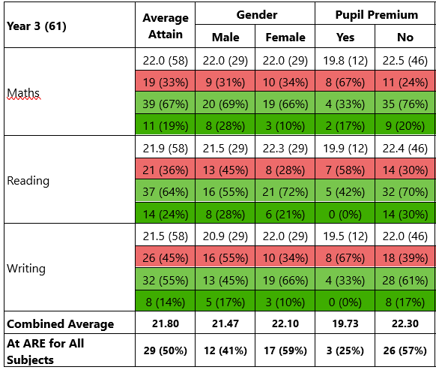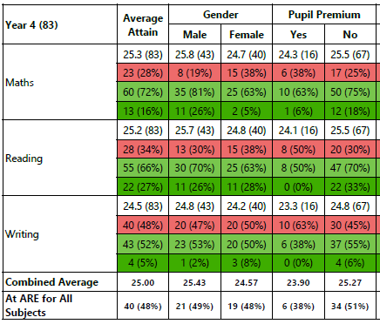
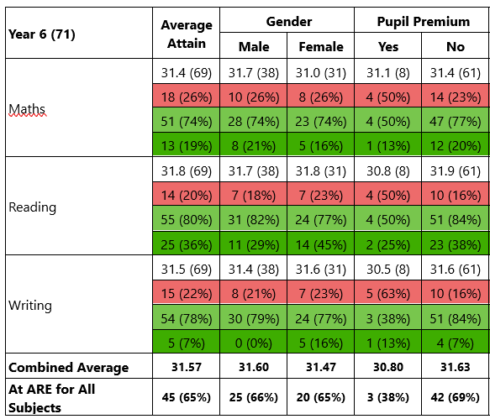
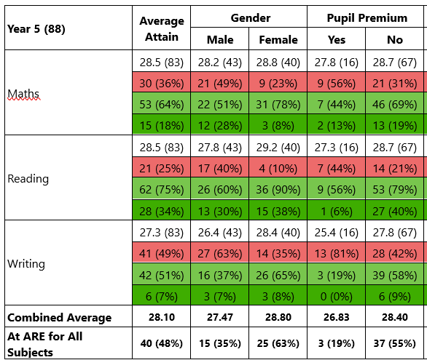
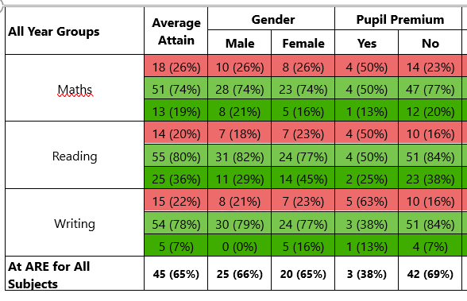

Externally provided programmes
Please include the names of any non-DfE programmes that you purchased in the previous academic year. This will help the Department for Education identify which ones are popular in England
Programme | Provider
Reading Eggs | Reading Eggs
Book in a Box | Book in a Box

Service pupil premium funding (optional)
For schools that receive this funding, you may wish to provide the following information:
Measure | Details
How did you spend your service pupil premium allocation last academic year? | N/A
What was the impact of that spending on service pupil premium eligible pupils? | N/A

